Schedul - wait() now() Ling report
Alwyn Barnard 28430093

Table of Contents
Introduction to Scheduling 2
CPU and I/O Process Bursts 2
Pre-emptive vs. Non-pre-emptive Scheduling 3
Categories of Scheduling Algorithms 3
Batch Systems 4
Interactive Users 4
Real Time Constraints 4
Goals of Scheduling Algorithms 4
Scheduling Algorithms 5
Batch Scheduling Algorithms 5
First-come First-Served (FCFS) 5
Shortest Job First (SJF) 5
Shortest Remaining Time Next (SRTN) 6
Interactive Systems Scheduling Algorithms 6
Round-Robin Scheduling 6
Priority Scheduling 6
Multiple Queues 6
Shortest Process Next (SPN) 7
Guaranteed Scheduling 7
Lottery Scheduling 7
Fair Share Scheduling 7
Conclusion 7
Program GUIs 8
References 9

Introduction to Scheduling

Central Processing Unit (CPU) Scheduling is a process that allows a single process to use the CPU while other processes are in a waiting state or on hold. This is usually because there is some kind of resource that is unavailable or not yet received, like input or output from the user. With CPU Scheduling the system is efficient and fast without unfairly distributing its processing (Singh et al., s.a.).
Whenever a computer’s CPU is in idle mode, it is the job of the operating system to select a process in the ready queue to be executed next. The part of the operating system whose sole job is to do this is called the Scheduler. The algorithm used is called the Scheduling Algorithm.

Along with having to choose the appropriate process to run, the CPU also has to make sure that it is being efficient, since process switching is time and resource consuming. The following is a brief summary of the steps that the CPU has to go through: (Tanenbaum & Bos, 2014:144).
- The CPU has to switch from its User mode to the Kernel mode.
- The state of the current process has to be changed from idle to ready, and its registers have to be stored in a process table.
- Then a scheduling algorithm must pick the next process from the list of idle processes.
- The Memory Management Unit (MMU) must then be reloaded with the data of the next waiting process.
- And lastly, the CPU has to start and execute the process it has chosen.

CPU and I/O Process Bursts
All processes alternate between two states in a continuing cycle in the CPU. Typically, the CPU will run without stopping and then receive a system call to read or write from or to a file in memory. After completion, the CPU will run again until another system call for data is received (Tanenbaum & Bos, 2014:145). A CPU burst can be defined as a burst of calculations etc., and an I/O burst can be defined as the waiting process for receiving data as input or providing output to the system (Bell, 2009).

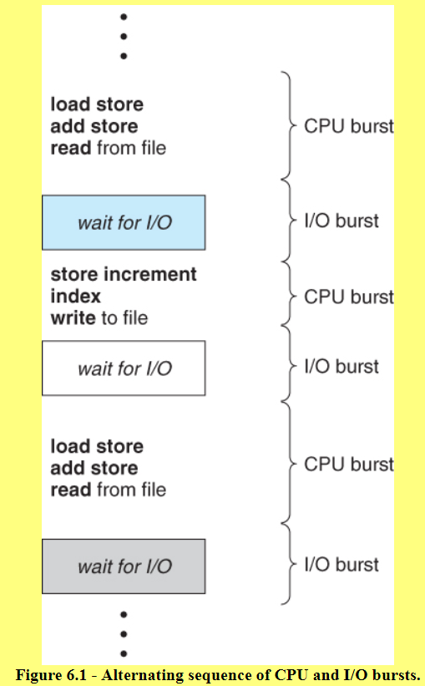
(Silberschatz et al., 2013).
In the above image we can see that there are processes that have long CPU bursts and very infrequent I/O waits. This is called a Compute-bound process. On the other hand, there are also I/O-bound processes, that do not do much computing between I/O requests. The key factor in the former is the length of time of CPU bursts and in the latter the length of time of computing between long I/O waits (Tanenbaum & Bos, 2014:146).

Pre-emptive vs. Non-pre-emptive Scheduling
There are two categories of CPU scheduling, Pre-emptive and Non-pre-emptive. The key factor is how they deal with a clock interrupt. Pre-emptive scheduling picks a process and then lets it run for a specific allotted time that is fixed. When the end of that time is reached, the process is suspended, and another process will then start and be run for the fixed allotted time. With pre-emptive scheduling a clock interrupt will be executed at the end of the fixed time and then hands over control of the CPU to the scheduler. It there is no clock then non-pre-emptive scheduling will be implemented.
Non-pre-emptive scheduling algorithm will pick a process and let it run only until it blocks by waiting for another process or on I/O, or when it voluntarily releases the CPU. This means that the process can run for hours or forever in a never-ending loop.

Categories of Scheduling Algorithms
Different scheduling algorithms will give priority to different processes, and we need these different algorithms because in different settings, specific processes need priority. We categorise these settings into three categories: Batch Systems, Interactive Users, and Real Time Constraints.

Batch Systems
In a Batch System there is no user waiting for the result of a small request. Instead, large amounts of process and data are handled in big chunks and then only will output be given. Here, both pre-emptive and non-pre-emptive scheduling algorithms can be used as both of these algorithms reduce the amount of process switches and will thus improve the performance of the CPU (Tanenbaum & Bos, 2014:147).

Interactive Users
Interactive systems have an environment with interactive users, and thus pre-emption is essential because of the fixed amounts of process time. This means that when a device, like a server, needs to schedule a process, then the users would not have to wait long periods of time as with non-pre-emption. The risk of one process shutting the others out will then be eliminated because a clock interrupt will always allow the next process to execute (Tanenbaum & Bos, 2014:147).

Real Time Constraints
According to Tanenbaum & Bos (2019:147) a Real Time System can make use of either pre-emptive or non-pre-emptive Scheduling. They believe that pre-emptive scheduling wouldn’t always be necessary because the processes know that they would not execute for a long time and would automatically call the next process.
What is the difference between a Real-Time system and an Interactive System? The difference lies within the functioning and type of process that is being run by each system. A Real-time system will mostly only run a process that will further or somehow support an existing process or program (Tanenbaum & Bos, 2014:147).

Goals of Scheduling Algorithms
To be able to design an inclusive and faultless algorithm for CPU Scheduling a few guidelines or goals should be taken into consideration:
- In all systems, Fairness is very important. If one process is given more CPU time than another it would mean that one part or program will lag and cause the compute to be slow because one of its parts have fallen behind. Also, the goal of a scheduling algorithm is for the user not to notice that there is only one process being executed at once. We want the user to believe, and the computer to act like, all processes and all parts get to the CPU at the same time and are executed at the same rates.
- Enforcing the System’s Policies. Let’s look at an example. A user plugs a USB device into the computer to execute a Word document and edit some of its contents. Policy would be for the Anti-Virus software to scan the drive BEFORE it is opened. If this policy had to take the back seat because the process to play the sound for entering a USB drive took president, then the algorithm would be ineffective.
- Keep all the parts of the system busy. The reason for this is because if the system is let to idle, and then receives a system call or request then the time it too to wake up all the parts of the system and again store some information in registers etc., would take a substantial amount of time to do. Unnecessarily, time is wasted. If the system is kept busy then a system call would only illicit a change in process and the execution of a new process.
- Batch Job Goals:
  - Throughput: Throughput is the number of jobs that is completed for every hour the computer is awake. The throughput is measured by taking the average of the time a batch job started and ended and calculating the result. Throughput isn’t always that effective in minimizing turnaround time.
  - Executing 60 jabs is definitely better than executing 40 jobs, but when an algorithm only lets smaller jobs execute and no bigger jobs then the turnaround (loading, changing state, memory management and execution of a process) is very slow. This results in a computer with a lot of lag.
  - CPU Utilization: This refers to the amount of usage of processing resources of the computer and the amount of work that were handled and successfully executed by the system (Janssen & Janssen, 2019).
- Interactive System Goals:
  - Minimize Response Time: Response time refers to the time it takes between when a command is given and when a result is received. A user might want to open a program like Visual Studio, whilst in the background they are using a time to calculate the time they are spending on a project. In this scenario the priority of the computer has to be to open the program and let the background process, the time, do its own thing uninterrupted.
  - Proportionality: This concept refers to the notion that the actual time something takes to execute and the perceived time should not be fundamentally or very largely different (Tanenbaum & Bos, 2014:149).
- Real Time Systems:
  - Deadlines that must be met: If a computer is controlling a process that freuquently and at a fixed rate provides data to a device and this suddenly stops then a huge error can occur, sometimes fatal.
  - Predictability: The concept of predictability comes into play when multimedia, especially videos, need to be rendered to avoid the result that sound is “scratchy” and video is “jittery”

Scheduling Algorithms

Batch Scheduling Algorithms

First-come First-Served (FCFS)
This scheduling algorithm is a pre-emptive algorithm that will assign processes to the CPU in the order that they are received. This is like standing in a line to go through a door. The first one there will enter first, the second person will enter second etc. This algorithm uses a single queue to execute processes. If the process is in a block or wait state it is added to the back of the queue and the next in line is executed.
This algorithm is very easy to implement and understand (Tanenbaum & Bos. 2014:150). Especially if a Linked List is used to remove an item from the beginning of a list and to be added to the back, by simply changing the tail value to that node’s address and assigning head’s value to the second value’s address.

Shortest Job First (SJF)
Shortest Job First is a non-pre-emptive scheduling algorithm that would look at all the processes that are in memory and then sort them in order of length, where the smallest is first. If two or more processes are equal in length, then the concept of FCFS is implemented.

Shortest Remaining Time Next (SRTN)
Shortest Remaining Time Next is a pre-emptive algorithm that will depend on the scheduler to look for the process with the shortest processing time remaining, and then execute that process next. It will also take into consideration any new processes that have added, but on a FCFS basis.

Interactive Systems Scheduling Algorithms

Round-Robin Scheduling
These are the steps to the Round Robin Scheduling Algorithm: (Tanenbaum & Bos, 2014:152).
Each new process is given a time interval. This is called a quantum. This is the time that it is allowed to do its processing. At the end of a process’ quantum, a new process is run. When the process is finished, the CPU switches to a new one.
The only issue with a Round Robin schedule is the length of the quanta. The switching between processes take some of the time in the quanta and thus “steals” from the process.

Priority Scheduling
When not all processes are equally important (as Round Robin assumes), then the Priority Scheduling Algorithm is the correct one to use. It assigns or requests that all of the processes get a priority number, and then executes them in that order. When two or more processes have the same priority then the principle of FCFS is.
If a process is in danger of running indefinitely, the scheduler may decrease its priority to save CPU resources and allow another process to run.

Multiple Queues
The Multiple queues algorithm uses the concept that a bigger process that needed more CPU time and that became an interactive process later on, be punished by setting its priority low or by running it last in the case of SJN. In this algorithm, quanta of sizes 1, 2, 4, 8, 16, 32, 64 etc are set up and each process is then run in the first and moved to the second. With each execution the queue is moved up to a different quantum and thus time is saved with the execution of the queues in bigger chunks.

Shortest Process Next (SPN)
Because the Shortest Job First algorithm will always choose the shortest batch and not include new processes, the Shortest Process Next has a new spin on the interactive process. It will look for the shortest job everytime it is ready to execute the next job, so if a new process were added the that process will be taken into consideration too (Tanenbaum & Bos, 2014:156).
The selection of which Process is shortest is determined by an algorithm that is dependent on the type of System and Operating System that have been installed.

Guaranteed Scheduling
One very different approach to scheduling is to make an actual “promise” to the CPU that a process will be executed. This is done with a simple equation:
Time of each equation = 1 / n where n is the number of processes.
Each process in a 25-process system will then have: 1/25 = 0.04 of the total CPU time. Multiple equation are used in a typical operating system and the equation that produces the smallest/lowest ratio is then chosen to execute the processes.

Lottery Scheduling
Lottery scheduling is used when the other Scheduling Algorithms are too difficult or draining on the CPU. What Lottery Scheduling entails is that each process is given a random ticket. Then when the CPU is ready to execute the next process then a ticket is randomly chosen, and the corresponding process is executed. This algorithm also assumes that all process was created equally, at the same time and with no other conflicting data that would better fit a different algorithm.

Fair Share Scheduling
Assume for instance that we have two processes A and B respectively. Process A has 4 parts or threads to it and Process B only has one. In Fair-Share Scheduling the total CPU resources are divided between A and B equally (50-50) and then each’s share is the divided equally among all their child threads. This means that Process A’s 4 threads will then each get 25% of the total awarded to A, and they will receive 12,5% of the overall CPU resources.

Conclusion
Scheduling is necessary to facilitate the process of timesharing of the CPU resources and this is determined by select algorithms. These algorithms have three overarching categories, Batch, Interactive and Real-Time. Batch systems can be scheduled using First-come First-served, Shortest Job First, and Shortest Remaining Time Next. Interactive Systems can be scheduled with Round-Robin, Priority, Multiple Queues, Shortest Process Next, Guaranteed Scheduling, and Lottery Scheduling. Each algorithm falls into one of two categories: Pre-emptiable and Non-pre-emptiable.

Program GUIs
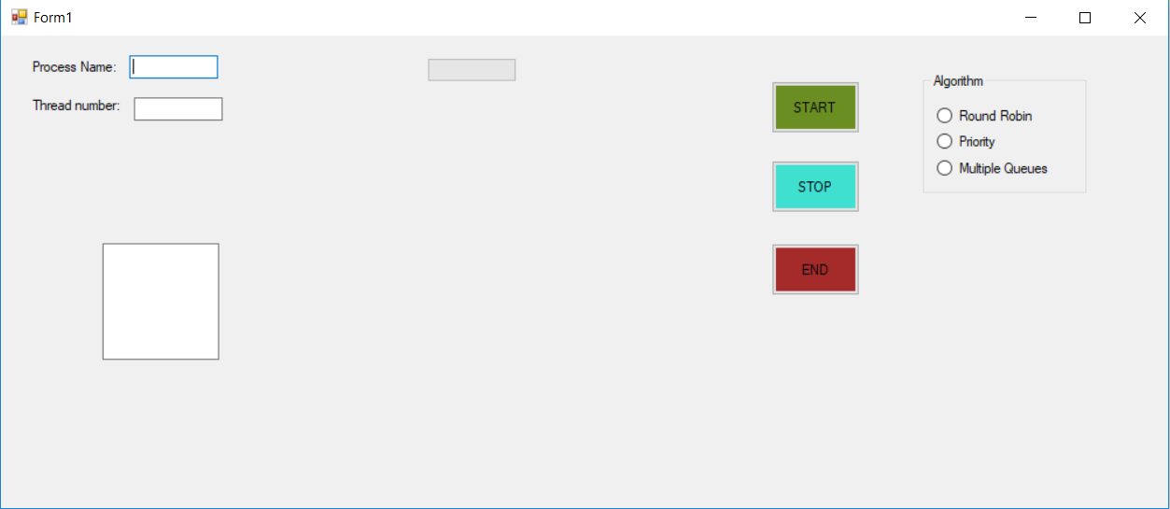

Seen above is the GUI for a Round Robin or Multiple Queues Schedule. The object in the middle (A Progress bar) will be used to indicate the total progress of the program. Below is the GUI for a Priority Scheduling Algorithm. It has an additional Textbox to receive priority as input.

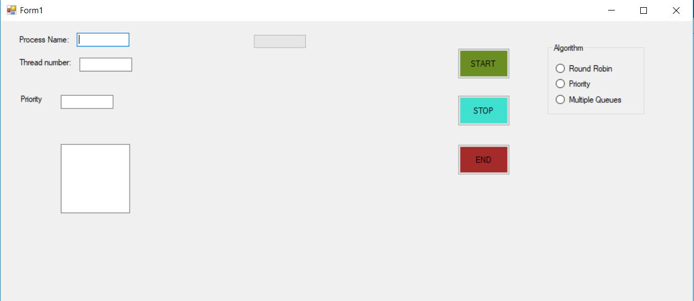

References
Bell, J. 2009. CPU scheduling. Chapter 6. https://www.cs.uic.edu/~jbell/CourseNotes/OperatingSystems/5_CPU_Scheduling.html Date of access: 15 Mar. 2019.

Janssen, D. & Janssen, C. 2019. CPU Utilization. https://www.techopedia.com/definition/28291/cpu-utilization Date of access: 18 Mar. 2019.
Silberschatz, A., Galvin, P.B. & Gagne, G. 2013. Operating system concepts. https://www.academia.edu/34752590/Abraham_Silberschatz_Peter_B._Galvin_Greg_Gagne_Operating_System_Concepts Date of access: 15 Mar. 2019.

Singh, A., Diwan, A., Kaushik, J., Kumar, K., Beniwal, M.S., Singh, V., Gautam, N., Joshi, V.P., Singh, G., Kaur, H., Upreti, G., Roy, G., Agarwal, A., Mandpe, S., Sinha, S., Raninga, K., Raj, R. & Chopra, A. s.a. Operating system. What is CPU scheduling? https://www.studytonight.com/operating-system/cpu-scheduling Date of access: 15 Mar. 2019.

Tanenbaum, A. & Bos, H. 2014. 4th ed. Boston, MA:Dorling Kindersley Pearson Education.

